AI Use Declaration Form
Course: Introduction to Artificial Intelligence
Lab Title: Lab 1 Part A — Uninformed Search Algorithms
Student Name: _______Jeffrey Otoo____________________________________________
Student ID: _____14302028_________________________________________________
GitHub Repository Link: https://github.com/JeffreyOtoo/Otoo_Jeffrey_Lab0
Date Submitted: 05/06/2026

1. AI Use Summary
Question | Student Response
Did you use any AI tool for this lab? | Claude
Estimated percentage of the work influenced by AI | % 22
Did you attach evidence of AI use where applicable?

2. Details of AI Use
Complete the table below for each AI tool used. Add more rows where necessary.
Name of AI Tool Used | Purpose for Using the Tool | Prompt or Instruction Given to the Tool | Part(s) of the Work Influenced by the Tool | How I Verified, Edited, or Improved the AI Output
Claude | To help create github repo using terminal | Im trying to create a repo on github through terminal but I am a bit confused. Can you go through this code(2.2) and explain it to me | Section 2.2 | Was able to login to github from terminal and create a repo
Claude | To break down section 4.1, 4.2 and 4.3 | (pasted github link). Please go through section 4.1, 4.2 and 4.3 and give me a detailed breakdown of the code and what each line does | 4.1, 4.2, 4.3

3. Attachment of AI Output Evidence
Where required, attach evidence of AI use. Tick all that apply. Add more rows where necessary.
Evidence Type | Attached? (Yes, No, N/A) | File Name
AI-generated draft
Prompt history | Yes | 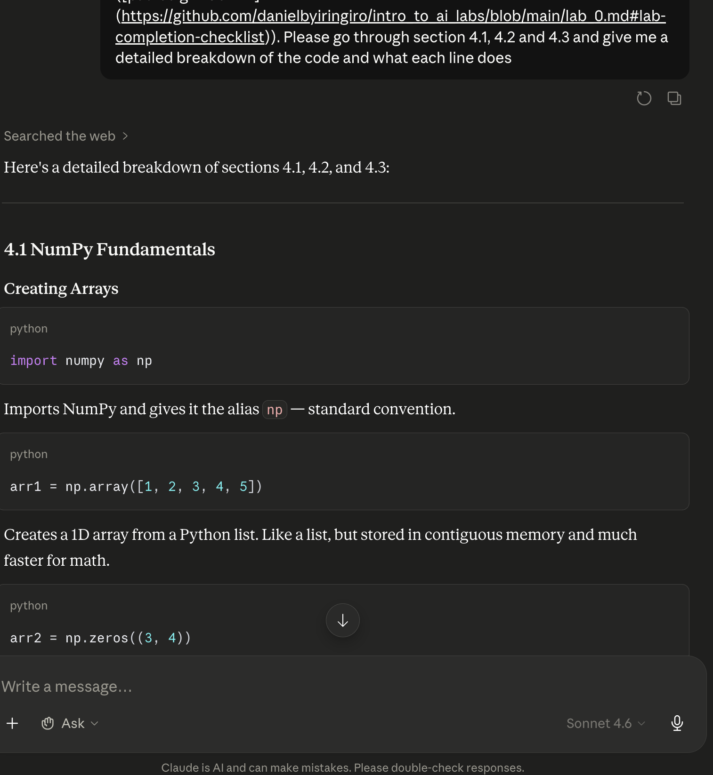
Screenshot of AI interaction
Exported AI conversation
AI-generated code snippet
Revised version showing student input

4. Student Declaration
I declare that:
Declaration Statement | Response (Yes/No)
The submitted work is my own work. | Yes
Any use of AI tools has been clearly declared in this form. | Yes
The prompts, instructions, and AI-generated outputs have been disclosed where applicable. | Yes
I reviewed, tested, edited, and improved any AI-generated content before submission. | Yes
My AI usage does not exceed 25% of the entire work. | Yes
I understand that undeclared or excessive AI use may be treated as academic misconduct. | Yes

Student Signature: ____________Jeffrey Otoo_______________________________
Date: ____________05/06/2026_______________________________

